Exercise 1: Complete below tasks as part of this exercise:
a)
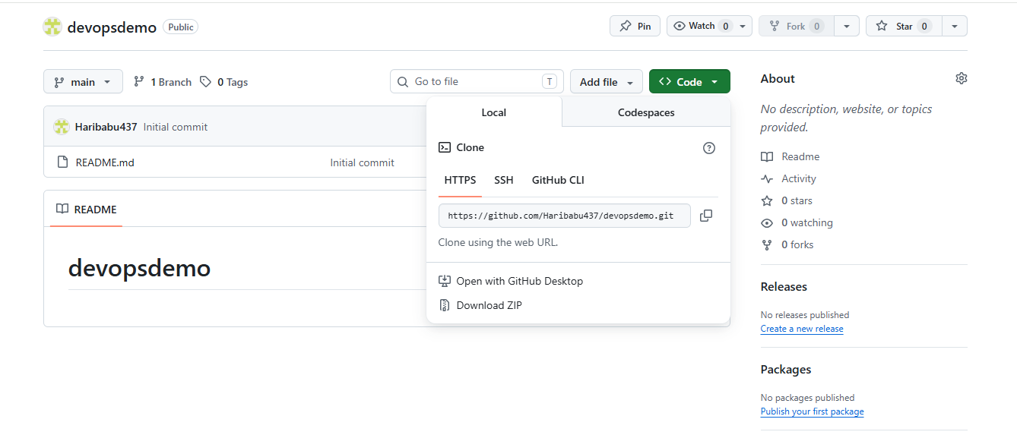

b) Clone this repo 'devopsdemo' to your GCP compute instance

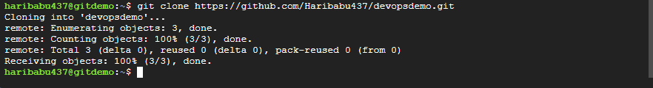

c) cd to the repo directory you just cloned

d) Check the branch name you are checked out currently. It should be master by default.

e). Add two files using vim editor as below:

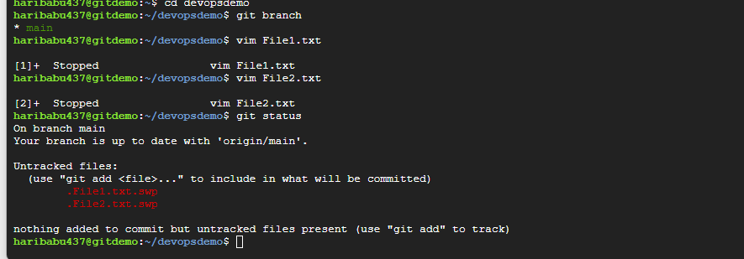

g) Add and Commit the changes to the repo

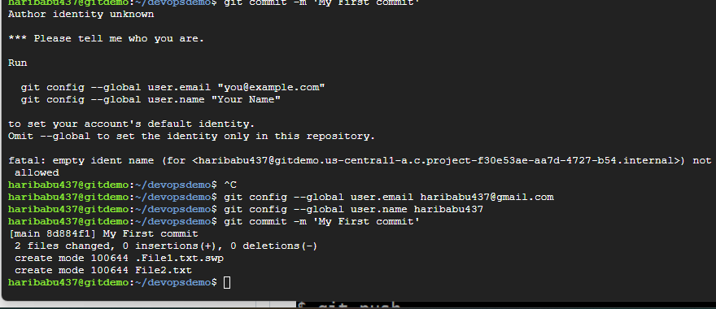
h) Push the changes to the repo 'devopsdemo' to github account

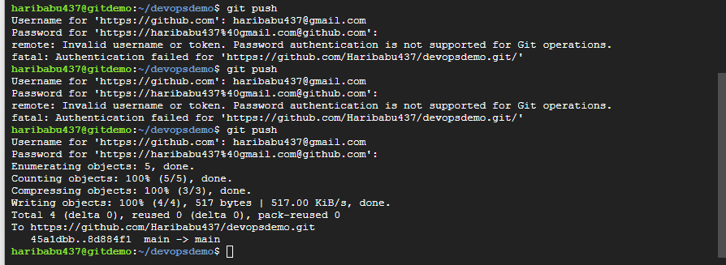
Files successfully pushed to Github account in the devopsdemo repo as below:
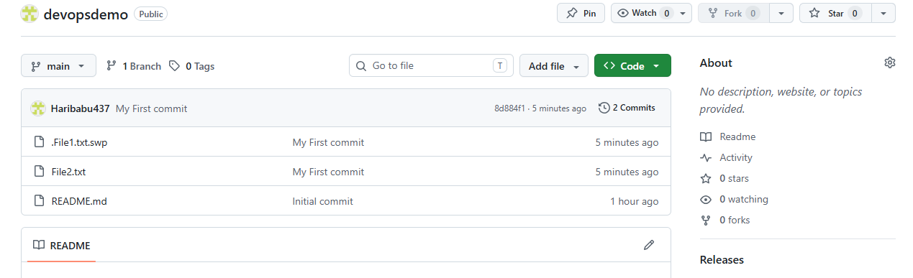

Exercise 2: Complete below tasks as part of this exercise:
- cd to the repo directory 'devopsdemo' on the server

- create a new branch with name feature1

- Checkout to feature1 branch

d) Add two files using vim editor as below:
- File3.txt
- File4.txt
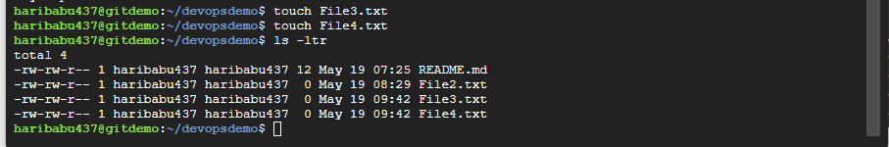

- Check status, add files, commit and push to github account
- 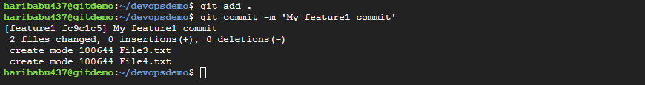

- Merge the changes in feature1 branch to master branch
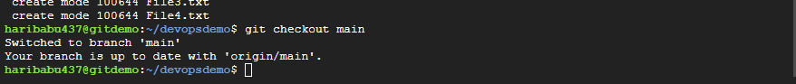

Before git merge you will see only old two files in main branch as below:

Now merge feature1 to main branch

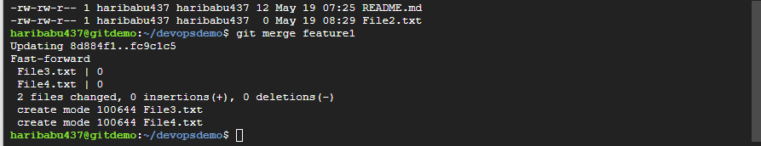

- Check if all changes from feature1 branch are available under master branch after merge.

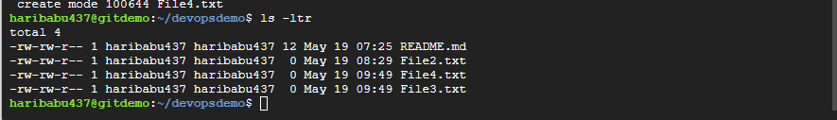

2 Files successfully pushed to Github account in the devopsdemo repo as below:

